**DAILY ONLINE ACTIVITIES SUMMARY**

|  |  |  |  |  |  |  |  |  |
| --- | --- | --- | --- | --- | --- | --- | --- | --- |
| **Date:** | **2/05/2020** | | | | | **Name:** | **SPOORTI S DAROJI** | |
| **Sem & Sec** | **4th SEM. & ‘B’ SEC.** | | | | | **USN:** | **4AL18CS088** | |
| **Online Test Summary** | | | | | | | | |
| **Subject** | | **1)MICROCONTROLLER AND EMBEDDED SYSTEM**  **2)ADALITHA KANNADA** | | | | | | |
| **Max. Marks** | | **1)20**  **2)50** | | **Score** | | | **1)19**  **2)35** | |
| **Certification Course Summary** | | | | | | | | |
| **Course** | **Python for Machine Learning** | | | | | | | |
| **Certificate Provider** | | | **Greatlearning**  **academy** | | **Duration** | | | **5 Hrs.** |
| **Coding Challenges** | | | | | | | | |
| **Problem Statement 1: C program to find digital root of a number**  **Problem Statement 2: C program to In an array X of size M where the array elements contain values from 1 to M with duplicates, the task is to find the total number of sub arrays which start and end with the same element.** | | | | | | | | |
| **Status: Executed.** | | | | | | | | |
| **Uploaded the report in Github** | | | | | **Yes** | | | |
| **If yes Repository name** | | | | | [alvas-education-foundation](https://github.com/alvas-education-foundation)/[spoorti_daroji](https://github.com/alvas-education-foundation/spoorti_daroji) | | | |
| **Uploaded the report in slack** | | | | | **Yes** | | | |

**Online Test Summary:**

* **The 18CS44 test was scheduled from 12:00PM to 12:50PM.The Portion for the IA was the 2nd module there were 20 questions of one mark & the time assigned was 40 minutes. The questions were mcq type.**
* **The 18CS49 test was scheduled from 2:00PM to 2:50PM.The Portion for the IA was the 2nd module there were 50 questions of one mark & the time assigned was 50 minutes. The questions were mcq type.**

**Online Certification course Summary:**

**In today’s session I have learnt about the Pandas Combining DataFrames.**

**The ways dataframes combined in pandas is similar to SQL we will examine 3 methods for combining dataframes.**

1. **Concat**
2. **Join**
3. **Merge**

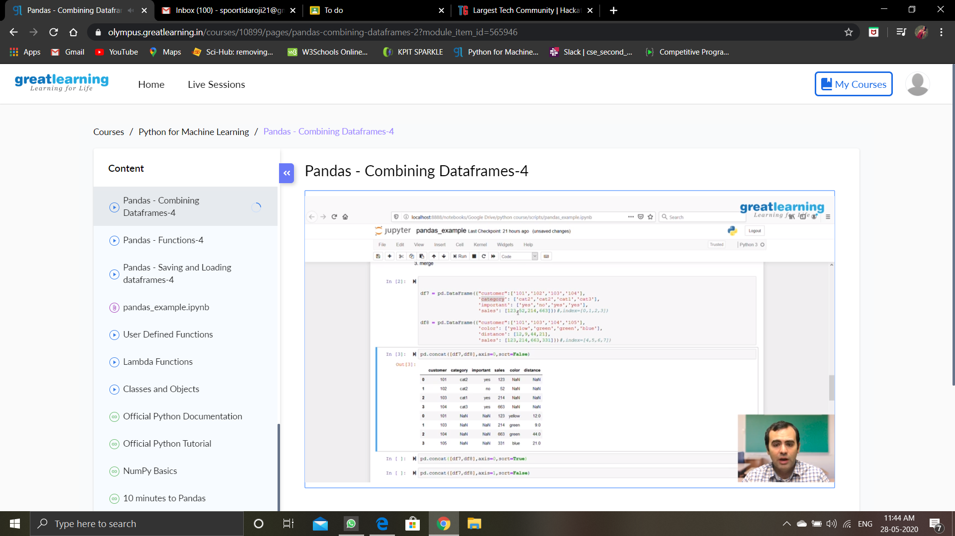

**Online Coding Summary: Today I received the program from prof.Merlyn Mathias CSE Dept, and prof.Vasudev.S CSE Dept.**

**The program is mentioned above in the coding challenges.I have written a program and uploaded it to my Github repository, as shown in the below.**

